Jessica Zeramby

July 30, 2021

Final Project: BIO 539

**An Exploratory Analysis of Wildlife Rehabilitation Admission Records**

*A case study based in southern Rhode Island*

**Introduction**:

Despite a long history of coexistence, the frequency of human-wildlife interaction has increased in recent decades (Schell et al. 2021). As a result, a variety of positive and negative interactions between humans and wildlife have occurred, each with their own set of consequences (Nyhus 2016). Recent literature has widely acknowledged that continuous human population growth, as well as the resulting expansion of human settlement into wildlife habitats, has increased the likelihood of regular human-wildlife interactions (Distefano 2005). As pressure on natural systems continues to grow, the severity of these conflicts is likely to worsen. Therefore, while many aspects of human-wildlife interactions are heavily influenced by geographic location and the species involved, the likelihood of these interactions occurring is not limited to any one area or environment. As scientists have become more aware of the importance of this knowledge, there has been a surge in interest in studies of human-wildlife conflicts (Yilmato and Takele 2019).

Despite a desire for more in-depth research, scholars' ability to conduct comprehensive studies on this subject have been limited due to practical difficulties in assessing wildlife and ecosystem health, identifying patterns in human-wildlife interactions that lead to conflicts, and quantifying the severity of impacts, level of damage caused, and associated costs of these conflicts to both society and wildlife (Marty et al. 2020; Molina-Lopez et al. 2017). However, some research indicates that a previously untapped and underutilized database could be useful in these studies. According to research, admission records from wildlife rehabilitation facilities have the potential to advance our understanding of human-wildlife conflicts (Trocini et al. 2016). Given that understanding patterns at the local level is the first step toward resolving conservation issues that span vast geographic areas, multiple species, and a diverse range of taxa, the findings generated from analyses of local wildlife admission records could be significant for future research in this field (Lopez et al. 2011). The purpose of this study was to demonstrate how wildlife rehabilitation data can be used as a valuable source of information for conservation management, specifically in relation to Rhode Island wildlife populations. In order to provide evidence in support of this theory, the following analysis was performed.

**Methods:**

This analysis utilized admission records from a wildlife rehabilitation facility in Saunderstown, Rhode Island, USA. This facility, known as the Rhode Island Wildlife Clinic, also serves as the headquarters for the Wildlife Rehabilitators Association of Rhode Island (WRARI). WRARI is a non-profit organization dedicated to promoting understanding and respect for all wildlife in Rhode Island through education and practical wildlife assistance **(**Wildlife Rehabilitator’s Association of Rhode Island, 2021). The Rhode Island Wildlife Clinic, the state's only fully operational clinic dedicated to the veterinary care and treatment of all Rhode Island's native wild animals, has taken in thousands of displaced, dislocated, and injured wildlife over the last twenty-five years to treat their injuries and rehabilitate them for successful release back into the wild. An analysis of WRARI intake records from 2014, 2016, 2018, and 2019 is performed here to gain perspective on local conservation issues and high risks to Rhode Island's local wildlife populations.

The following intake records were approved for use by WRARI and RI wildlife clinic staff and provided for the purpose of this study. This included admission records from 2014, 2016, 2018, and 2019, accounting for over 10,570 individuals admitted to the clinic from over 800 different species. Each set of yearly intake records accounted for every individual admitted to this facility each year, including both animals that were alive when they arrived at the clinic and animals that were dead when they arrived. Admission records were kept in a Microsoft Excel database from 2014 to 2019, with some years having insufficient data to be included in this analysis. For each individual animal admitted to the facility, the species, taxonomic group, date of intake, location the animal was retrieved from, and reason for admission were all recorded. Each individual's reason for admission or source of injury was recorded as stated by the veterinary professionals in charge of intake at the facility. At the request of the data source, some information was omitted from these intake records before they were included in this analysis. This included any private or personal information obtained from rehabilitators or those who admitted animals to the clinic, as well as any information that is not available to the general public.

The yearly admission records from each of the four years of data used in this analysis were first subjected to analyses specific to each yearly data set. Each yearly file was analyzed individually, beginning with organizing and filtering the intake records to correct any spelling errors, update any abbreviated terminology to the correct terminology, and fix any formatting errors that would prevent the analysis from running smoothly in the RStudio server, as well as to keep each record standardized. Because there is no standardized record keeping protocol that must be followed when collecting data for each year's intake log, there is some room for bias or human error in the data analysis. To avoid bias in future analyses, record keeping systems should follow a standardized protocol when naming, labeling, abbreviating, and grouping data recorded for each individual admitted to the facility and thus incorporated into each annual intake log. Each yearly admissions data set was analyzed to determine the number of monthly admissions to the clinic, the most common reasons for admission, and the most frequently admitted species in each year. Following that, all of the admissions data sets from each year were combined into a single data set to analyze these same components across all years and from one year to the next. All analyses were run through the RStudio server to generate statistical and visual outputs for each of these components.

The first half of this analysis focused on analyzing each set of individual yearly intake records separately, beginning with the first year of available data in 2014 and ending with the most recent year of available data in 2019. The first step in this process was to determine the number of admissions reported in each month of each year. Admission numbers were plotted against the months of the year in a graph to visually display changes in admission numbers from one month to the next. This information was also presented in a table, which listed the total number of admissions in each month of the year. Admission counts were statistically analyzed to determine the month with the highest number of admissions, the month with the lowest number of admissions, and the average number of monthly admissions in each year. The number of admissions for injured wildlife and those in need of rehabilitation is critical for understanding the severity of human-wildlife conflicts on wildlife populations and assessing wildlife population and ecosystem health. This is important for understanding the severity of wildlife injury and displacement in the state as well as educating those who may be unaware of the problem's existence.

The following step in analyzing each year's admission records was to determine the top five most common reasons for admission to the facility in each year. This data is critical for understanding and assessing the severity of current threats to the state's wildlife populations, as well as identifying valuable mitigation strategies and focusing on the most beneficial management solutions. Each data set was grouped by the specific reason for intake for each individual admitted to the facility to identify the leading reasons for intake. The number of intakes was then counted for each of the five most common reasons for intake. The number of admissions for each of these five reasons was then plotted against each of these five reasons to visually display the reasons for intake that contributed the most admissions in each year. This information was also presented in a table format, and statistical analyses were used to include in the table the total number of admissions for each top reason for intake, as well as the percentage each reason accounts for all intakes in each year.

For each yearly admission record, a similar analysis was performed to determine the top five most frequently admitted species to the clinic. This procedure also required categorizing and counting the total number of admissions for each of the most commonly admitted species. The number of admissions for the top five most frequently admitted species was plotted against each of the five species. The data was then displayed in a table with the total admissions and percentage of total admissions associated with each of the top five most frequently admitted species. This information is critical for determining which species in the state are most vulnerable, which can help with species conservation education, species-specific policy development, and species protection management, planning, and implementation.

Finally, the second section of this analysis attempted to compare the outcomes of each of the individual yearly admission analyses. To begin, the monthly admissions plots generated from each of the yearly intake analyses, 2014, 2016, 2018, and 2019, were arranged in a two-by-two grid next to each other. As a result, a four-figure visual was created that allowed the monthly intakes for each year of data in the analysis to be easily compared to the preceding and following years of data. This visual tool provided a clear picture of the seasonal trends visible in the intake data for each year. This procedure was repeated to generate two more four-figure grids comparing the graphical results for the top five species admitted and the top five reasons for intake for each year. Once again, these grids provided clear visuals for trends in admission numbers associated with reasons for intakes and species commonly admitted in each of the years.

All of the individual yearly record data was then combined into a single data set in order to analyze all admission data collected during the study period, using a different approach to assessing data across all years in the study. This data set was evaluated to show the total number of admissions each month for all years, the top species admitted for all years, and the leading reasons for intake for all years. Following that, the total number of clinic admissions from each year of data in the study was computed. To visualize the number of yearly admissions, the total number of admissions was plotted against each of the four years of data included in the analysis. This information has proven to be useful for assessing trends, patterns, and changes in similar data sets over longer time periods. Finally, the merged data set was used to generate a map of Rhode Island that displayed the towns with the most animals admitted to the clinic. This can be an extremely useful tool in determining which areas of the state are most vulnerable to wildlife harm or injury.

**Results**

During the four-year study period, a total of 10,570 individuals from over 800 different species were admitted to the rehabilitation facility and were included in this analysis. The information in Supplemental Figures 1-12 and Supplemental Tables 1-12 is specific to each yearly admission record data analysis. Because the sample size and accuracy of each yearly admission record varied, the results of the individual yearly admission record analyses were not deemed significant for the overall outcome of this data analysis. However, comparing the plots generated by each of the four yearly admission data analyses side by side proved significant for comparing trends and changes in admission data from year to year. Furthermore, the analyses run using the merged data set, which consisted of the combined yearly admission records from all four years of data, produced significant results that are applicable to the overall goals of this analysis.

Both methods of analyzing monthly admission records for all data included in the study period revealed that trends in monthly admission counts remained consistent across all years of data. Placing each year's monthly admissions analysis plots side by side, as shown in Figure 13, provided a simple solution for visually assessing trends and changes in monthly admission numbers from year to year. As shown in the figure, from 2014 to 2019, June remained the clear peak for admission counts in each of the four plots, indicating that June had the highest number of admissions across all years of data. This graphic also made it possible to identify seasonal trends in admission numbers. For example, the far left and right sides of each plot, which indicate the lowest data points in each data set, correspond to each year's winter months, which were consistent in having the lowest admission numbers year after year. Finally, as seen in each of the grid's four plots, admission numbers peak between May and August, when the plots reach their highest point at the center. Admissions then fall exponentially in the late autumn months before plateauing and falling to a low point in the winter, during which admissions remain stable until they begin to rise again in the early spring months.

In the second approach to assessing changes in admission counts across all years of data in this analysis, analyses were run on the merged data set, which combined all intake records in the analysis into a single file. The analysis performed on this merged data file produced a clear visual depiction of how severe the spring and summer admissions peak is in comparison to the fall and winter months, as shown in Figure 16. When monthly admissions are combined across all years of data, this plot clearly shows June admission counts as an outlier in the data, exceeding all other monthly admission counts and reaching over 200,000 admissions in June. As shown in Table 13, this is also true for the months of July and May, which stand out among the other months in the data set as the only other months with more than 100,000 admissions across all years of data, with July reaching just over 150,000 admissions and May falling just short. The clearest point of this visual, once again, is the drastic change in admission counts as the seasons and months of the year change. Although one could argue that this increase in admissions is to be expected in the spring and summer months because many New England species begin breeding, migration, or nesting season at this time of year, it is also likely that the influx of tourists, visitors, and locals who explore natural settings and open areas at this time of year may contribute significantly to increased chances of occurrence. As shown in Figure 17, the final segment of assessing changes and trends in admission counts over time looked at changes in the total number of admissions for each year, across all years of data in this analysis. Admission counts have remained on the higher end of the spectrum across all four years of data, though they appear to be increasing with each year. 2019 was the first year on record to see more than 3,000 admissions in a single year, a significant increase over previous years, with only 2,133 intakes in 2014.

The top five most common reasons for intake to the clinic, as well as the top five most commonly admitted species, were evaluated in a similar manner across all years of data in the study, as previously explained. Again, both the side-by-side comparison of yearly admission data and analyses run on the merged data set produced significant results for this analysis. As shown in Figure 14, a comparison of side-by-side yearly analyses reveals that orphaned young wildlife was the most common reason for intake to the facility in each of the four years. Orphanage admissions accounted for 18-40% of all admissions in each year of data. The second most common reason for admission was injuries caused by unknown trauma or an unidentified source, followed by domestic cat attacks on wildlife, and then by injuries to wings, vehicle-animal collisions, or domestic dog attacks on wildlife. The merged data analysis was then narrowed down to identify the top three most common reasons for intake across the merged data set, as illustrated in figure 18. The top three reasons for admission in all data sets were animal orphanage, cases of unknown trauma, and domestic cat attacks on wild animals. As illustrated in figure 15, the eastern cottontail and eastern grey squirrel remained the number one and number two most commonly admitted species, respectively, across all four years of data, followed by various bird species such as American Robins, Sparrows, Doves, and Gulls. Although, as shown in figure 19, when all years of intake records were merged, the analysis on this data set revealed that the house sparrow was more frequently encountered at the clinic than the eastern grey squirrel, ranking second in the merged data set analysis behind the eastern cotton tail.

Finally, to identify any locations in the state that serve as hotspots for wildlife harm or displacement, a map of the state was generated using the RStudio server, and the locations from which each individual was transported to the clinic were assessed to determine the Rhode Island locations with the highest admission rates, and thus the greatest risks to wildlife populations. The top ten towns with the highest admission rates were plotted on a map of the state in such a way that the size of each circle associated with each town name correlates to the number of admissions represented by each town, as explained in the legend. In terms of wildlife admissions, Warwick, RI led the way with over 1,400 admissions, followed by Providence with over 600 admissions.

**Discussion**

The original key questions addressed by this analysis were what the most common sources of injury for wildlife in Rhode Island are, which species are most threatened or vulnerable in the state, what the average number of intakes to the wildlife clinic are, and if any locations in the state serve as hot spots for wildlife injuries or harm. The analyses performed here were successful in answering these critical questions. This analysis was significant in that it provided evidence to support new and upcoming scientific approaches to understanding and mitigating human-wildlife conflicts using wildlife rehabilitation record analyses. This is because, with only four years of data, the leading causes of injury were determined as indicated by common reasons for intake to the clinic, as well as the most commonly admitted species, or species most at risk in the state, and the number of average intakes to the facility, as well as hot spot locations in Rhode Island, were all easily evaluated through the use of wildlife admission records. While this analysis may not solve the problem of human-wildlife conflicts in Rhode Island today, it can be used to lay the groundwork for future research and advances in this field of science.

**References**

Balasubramaniam, K.N., Marty, P.R., Samartino, S. et al. Impact of individual demographic and social

factors on human–wildlife interactions: a comparative study of three macaque species. Sci Rep 10, 21991 (2020). https://doi.org/10.1038/s41598-020-78881-3.

Dickman, A.J. 2010. Complexities of conflict: the importance of considering social factors for

effectively resolving human–wildlife conflict. Animal Conservation, 13: 458-466. <https://doi.org/10.1111/j.1469-1795.2010.00368.x>.

Nyhus, P.J. 2016. Human-Wildlife Conflict and Coexistence. Annual Review of Environment and

Resources 41:143-171. <https://doi.org/10.1146/annurev-environ-110615-085634>.

Yilmato, A., & Takele, S. 2019. Human-wildlife conflict around Midre-Kebid Abo Monastry, Gurage

Zone, Southwest Ethiopia. International Journal of Biodiversity and Conservation, 11(8), 212-229.

Molina-López RA, Mañosa S, Torres-Riera A, Pomarol M, Darwich L (2017) Morbidity, outcomes and

cost-benefit analysis of wildlife rehabilitation in Catalonia (Spain). PLoS ONE 12(7): e0181331.

Molina-López RA, Casal J, Darwich L (2011) Causes of Morbidity in Wild Raptor Populations Admitted

at a Wildlife Rehabilitation Centre in Spain from 1995-2007: A Long Term Retrospective Study. PLoS ONE 6(9): e24603. <https://doi.org/10.1371/journal.pone.0024603>.

Nyhus, P.J. 2016. Human-Wildlife Conflict and Coexistence. Annual Review of Environment and

Resources 41(1):143-171. <https://doi.org/10.1146/annurev-environ-110615-085634>.

Schell, CJ, Stanton, LA, Young, JK, et al. The evolutionary consequences of human–wildlife conflict in

cities. Evol. Appl. 2021; 14: 178– 197. https://doi.org/10.1111/eva.13131.

Yilmato, A., & Takele, S. (2019). Human-wildlife conflict around Midre-Kebid Abo Monastry, Gurage

Zone, Southwest Ethiopia. International Journal of Biodiversity and Conservation, 11(8), 212-229.

**Figures**

*Figure 13: Monthly Admissions by Year, 2014-2019*

*Figure 14: Top Five Reasons for Admission by Year, 2014-2019.*

*Figure 15: Top Five Common Species by Year, 2014-2019*

*Figure 16: Combined Total Wildlife Clinic Admissions by Month, 2014-2019*

*Figure 17: Yearly Admissions to the Clinic, 2014-2019*

*Figure 18: The total number of admissions and percentage of total admissions for each of the top three reasons for admission, by date from 2014-2019.*

*Figure 19: The top three most frequently admitted species and the total \n number of clinic admissions for each, 2014-2019.*

*Figure 20: The number of admissions from each of the top ten towns in Rhode Island with the highest admission rates*

**Tables**

*Table 13: Total monthly admissions to the wildlife clinic, 2014-2019.*

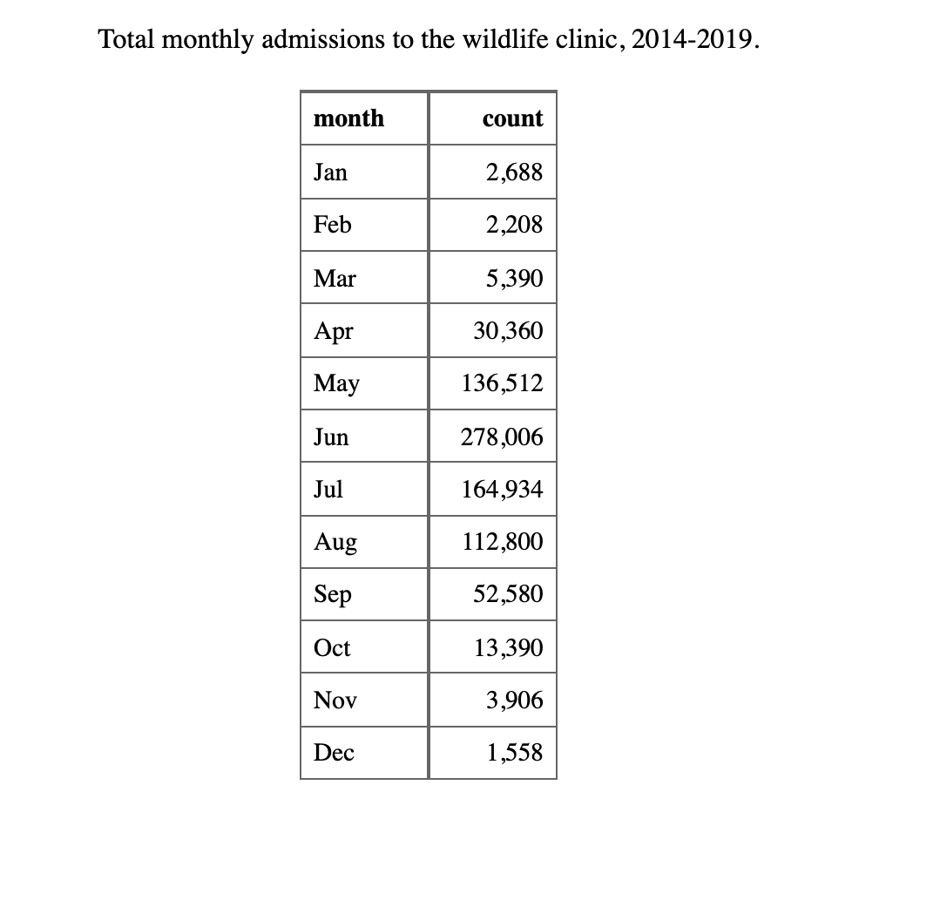

**Supplemental Figures and Tables**

*Supplemental Tables*

*Supplemental Figures*

